This User’s Guide is for the Samsung WiFi Speaker and Soundbar series user interface to the SmartThings environment. This guide was derived based on the Android SmartThings application firmware version 18.22.

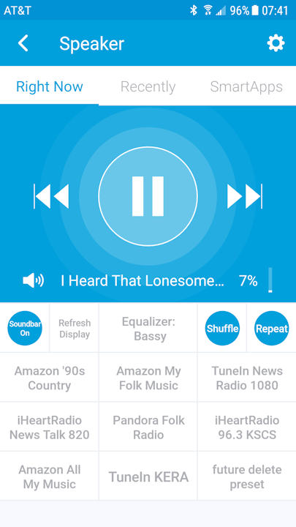

**Capability Summary**

* Channel / Music play
* Select channel/Music through Presets
* Control play of music/channels (started either from app or from Multiroom app).
* Shufle/Repeat
* Device Control
* Volume/mute
* Equalizer Presets
* Select device input source
* On/Off (Soundbars only)
* Rear Volume (Soundbars only)
* Future Planned
* Improved Preset setup
* Speaker Groups

**Details Page Description:**

The Speaker/Soundbar details page contains tiles defined in the following paragraphs, covered from top to bottom and left to right. The figure below is a summary of playback capability relative to each (current) player type.



**1. Music Play Control Tile.** The top-most tile is the large Music Play Control area.

a. **Previous** (left arrow set). A single press goes to the beginning of the current song. The second press goes to the previous song.

b**. Play/Pause**. Double bar, currently playing. Single right arrow, currently paused.

**c**. **Next** (right arrow set)**.** Single press goes to the next track.

d. **Mute** (speaker icon). Press once to toggle. Slash through icon indicates current setting is mute.

e. **Marquee**. Displays information dependent on the input source.

1. Source other than WiFi. Displays the long name of the source.

2. Source Wifi. Displays the Radio Station or, if available, music title information. If no information is available, displays “Unknown WiFi”

f. **Volume**. Brings up the SmartThings volume slider page. You select a volume from 0 to 100 PERCENT. The percentage then sets the device based on the max volume setting for the device (speaker: 30, soundbar: 100).

**2. Power Tile**.

a. Soundbar. Controls and displays the status of on / off. Color is blue when on and white when off.

b. Speaker. Displays “Speaker”. No action on pressing area.

**3. Refresh Display Tile**. Single action tile to refresh display data. Two useages:

a. Update the display when entering the app with the speaker/soundbar already play.

b. Synchronize display when it did not update automatically (usually due to slow communications between the SmartThings environment and the device.

**4. Equalizer Tile**. Toggle switch. Toggles between the Multiroom app pre-defined Equalizer states.

**5. Shuffle Tile**. Toggles between shuffle on or off. Blue when on, white when off. If shuffle is not available (see above figure), display “No Shuffle” with color white.

**6. Repeat Tile**. Toggles between repeat on or off. Blue when on, white when off. If Repeat is not available (see above figure), display “No Repeat” with color white.

**7. Preset Tiles**. There are currently eight (8) preset tiles. Pressing this tile will cause the speaker/soundbar to stop the current playing activity and open and start playing the preset channel or playlist. Setting up of presets is discussed later in this document.

**Note: If system has been inactive (off or paused) for a significant time, this action will also turn on the speaker/soundbar. In that case, “Update Display” may be required.**

**Note: Occasionally, due to communications delays, the preset button does not work. If preset is not apparent within 5 seconds try again.**

**7. Future delete preset tile**. Future capability.

**Preferences Page Description:**

The details page is accessed by pressing the GEAR icon in the upper right corner of the Details Page. Below discussion is from top to bottom of the page. On Exit, you can either ignore the changes (using the upper left “**<**” icon or save the changes using the upper right “**Save**” icon.

**Note: The source on this page is not updated based on selections from the Details Page. This can cause an out of sync condition that can interfere with the play functions.If saving the changes, assure that the Source is based on the current source. Otherwise, the source will change to the one selected.**

1. **Device and Status**. Display only if the device name and current status (Paused/Playing).

2. **Name Change**. Allows you to change the display name of the device.

3. **Update Icon**. Causes a page with available icons to pop-up for selection of the desired icon.

4. **Device IP**. Area for the device IP for this manual device handler. (This will go away when the Service Manager is completed.

5. **Speaker Source**. Pops-up a menu of all known speaker sources for either soundbars or speakers. Valid choices are:

a. Soundbars. Vary by model. All models have: “Bluetooth”, “Auxiliary”, “WiFi”, “HDMI(ARC) or Optical”.

b. Speakers: “Bluetooth”, “TV Sound Connect”, “WiFi”.

6. **Rear Speaker Level**. Soundbar only. Supports the add-on, non-WiFi rear speaker available for the Samsung Soundbars. Pops-up a display with values of -6 to +6 for selecting the rear speaker level.

7. **REMOVE** (very bottom of page). Remove the device from the system.

**Preset Management**

Preset Management has been added to the program that allows the use to add and delete presets (with some limitations.

I. TO ADD A PRESET

a. Find a preset with identification "vacant"

b. Have the channel/playlist playing on the speaker. Path limitations:

1. Amazon. playlists in "Playlists".

2. Amazon Prime. Playlists in "Playlists" or in <"My Music", "Playlists">

3. iHeartRadio. Channels in the "Favorites" folder.

4. Pandora. Stations aready at the top level.

6. TuneIn. No Limitation.

7. 8tracks. No Limitation.

8. Other content players. Programed for default, w/o limitation. May not work. If it works, great. If not, contact author.

c. Press the "vacant" preset tile. Text will change to "Add Preset?"

d. Press the preset tile again. Text will change to "updating" followed by title.

e. To not add the preset, do NOT press the preset tile a second time.

II. TO DELETE A PRESET.

a. Press the "Delete Preset" tile. Text will change to "SELECT PRESET TO DELETE". If you press this, the process will abort.

b. Press the preset you want to delete. Text on the Delete Preset tile will change to "PRESS TO DELETE preset_n".

c. Press the Delete Preset tile again (within 10 seconds) to delete the preset.